# **Tracking bird migration using Python-3**



Name: Priyanka Singh Name: Sayak Mallick

B. Sc IT Software Engineering & DevOps B. Sc IT Machine Learning

**Abstract**: As according to the Wikipedia, the Global Positioning System (GPS) is a global navigation satellite system that provides geolocation and time information to a GPS receiver in all weather conditions, anywhere on or near the Earth where there is an unobstructed line of sight to four or more GPS satellites. One fascinating area of research uses GPS to track movements of animals. This case study visualizes, examines and manipulates GPS data that is used to track flight patterns of birds.

One fascinating area of research uses GPS to track the movements of animals. It is now possible to manufacture a small GPS device that is solar charged, so you don’t need to change batteries and use it to track flight patterns of birds.

**Introduction:** We will use a small data set that consists of migration data for three Gulls named Eric, Nico, and Sanne. The datasets; used dataset csv file contains eight columns and includes variables like latitude, longitude, altitude, and time stamps. In this case study, we will first load the data, visualize some simple flight trajectories, track flight speed, learn about daytime, and much, much more.

**Aim:** To track the movement of three gulls namely –Eric,Nico & Sanne  
**Dataset:** CSV file from kaggle  
**Dependencies:** Matplotlib, Pandas, Numpy, Cartopy, Shapely  
**Repository (Github):**

**We will divide our case study into five parts:**1. Visualizing longitude and latitude data of the gulls.   
2. Visualize the variation of the speed of the gulls.   
3. Visualize the time required by the gulls to cover equal distances over the journey.   
4. Visualize the daily mean speed of the gulls.   
5. Cartographic view of the journey of the gulls.

**PART (1/5): Latitude and Longitude**   
In this part, we are going to visualize the location of the birds. We are going to plot latitude and longitude along the y and x-axis respectively and visualize the location data present in the csv file.

Python Program:

import pandas as pd  
import matplotlib.pyplot as plt  
import numpy as np  
  
  
birddata = pd.read_csv("bird_tracking.csv")  
bird_names = pd.unique(birddata.bird_name)  
  
# storing the indices of the bird Eric  
ix = birddata.bird_name == "Eric"  
x,y = birddata.longitude[ix], birddata.latitude[ix]  
plt.figure(figsize = (7,7))  
plt.plot(x,y,"b.")  
  
''' To look at all the birds trajectories,  
 we plot each bird in the same plot '''  
plt.figure(figsize = (7,7))  
for bird_name in bird_names:  
  
 # storing the indices of the bird Eric  
 ix = birddata.bird_name == bird_name  
 x,y = birddata.longitude[ix], birddata.latitude[ix]  
 plt.plot(x,y,".", label=bird_name)  
plt.xlabel("Longitude")  
plt.ylabel("Latitude")  
plt.legend(loc="lower right")  
plt.show()

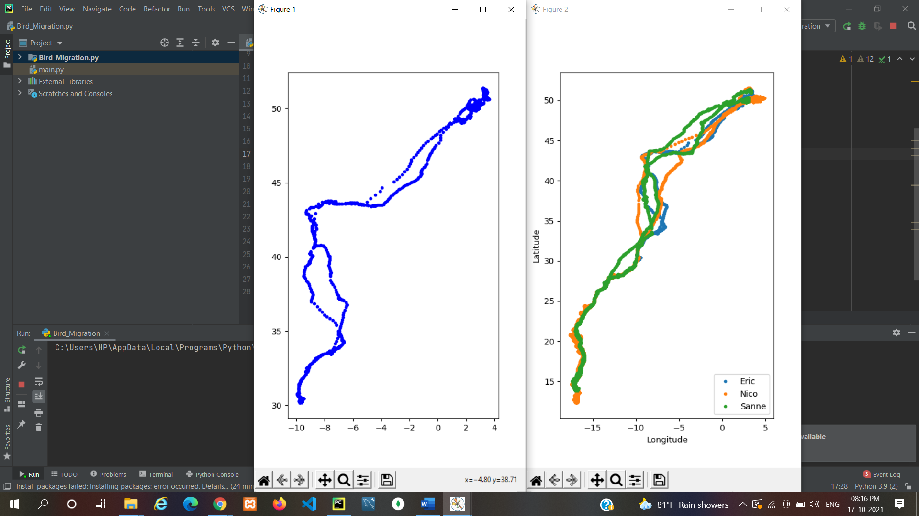

We use the matplotlib function, figure() to initialize size of the figure as 7 x 7 and plot it using the plot() function. The parameters inside the function plot() i.e x, y and “b.” are specifying to use longitude data along x axis(for x), latitude along y(for y) and b=blue, . = circles in the visualization.

**PART (2/5): 2D Speed Vs Frequency** :

In this second part of the case study, we are going to visualize 2D speed vs Frequency for the gull named “Eric”.

import pandas as pd  
import matplotlib.pyplot as plt  
import numpy as np  
  
birddata = pd.read_csv("bird_tracking.csv")  
bird_names = pd.unique(birddata.bird_name)  
  
# storing the indices of the bird Eric  
ix = birddata.bird_name == "Eric"  
speed = birddata.speed_2d[ix]  
  
plt.figure(figsize = (8,4))  
 plt.hist(speed[~ind], bins = np.linspace(0,30,20))  
plt.xlabel(" 2D speed (m/s) ")  
plt.ylabel(" Frequency ")  
plt.show()

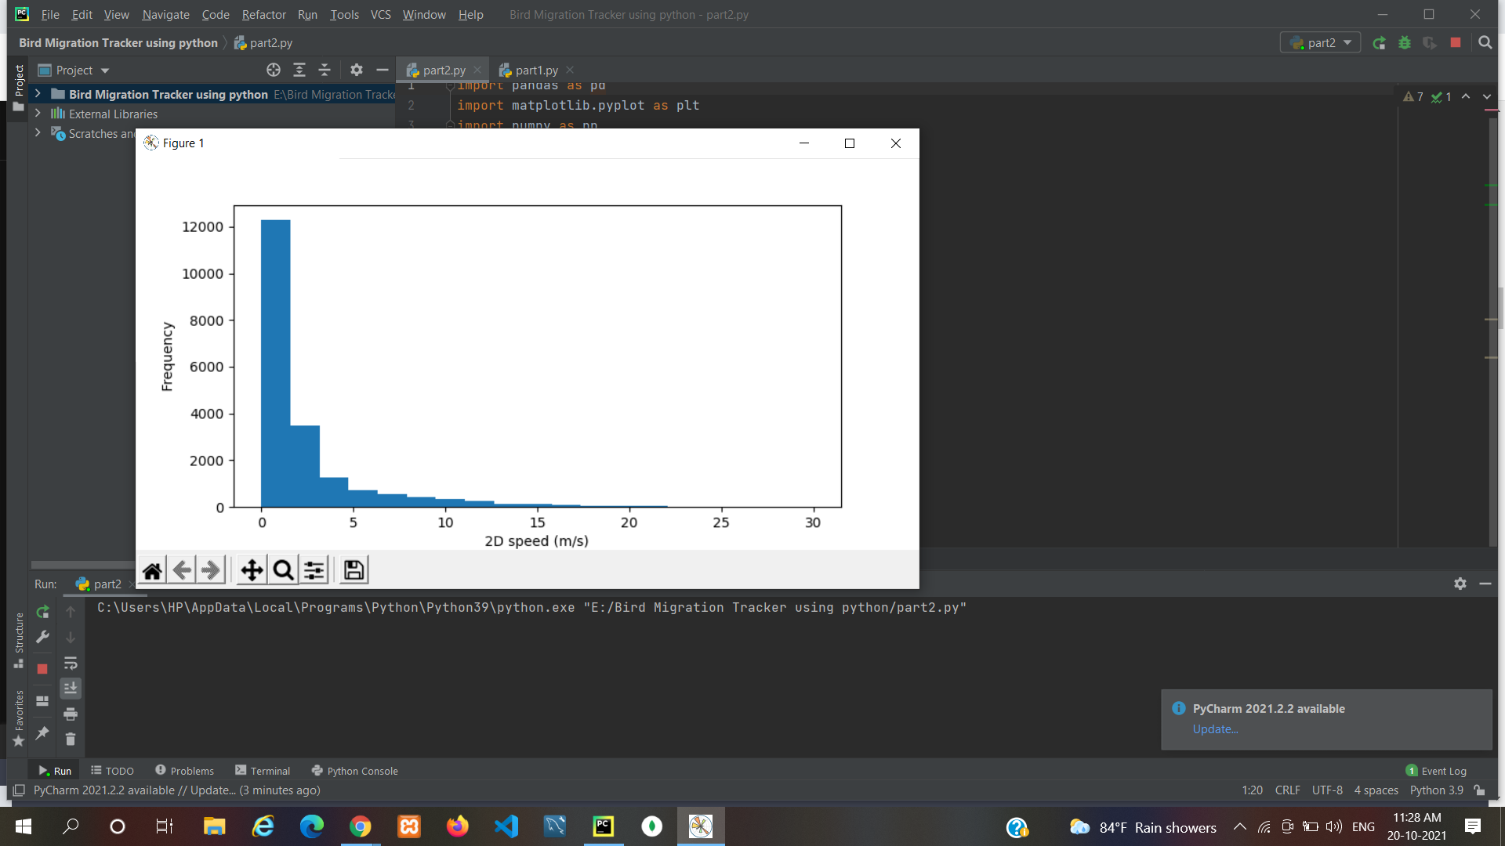

**PART (3/5): Time and Date**   
The third part is associated with date and time. We are going to visualize the time(in days) required by Eric to cover constant distances through his journey. If he covers equal distances in an equal amount of time, then the Elapsed time vs Observation curve will be linear.

import pandas as pd  
import matplotlib.pyplot as plt  
import datetime  
import numpy as np  
  
birddata = pd.read_csv("bird_tracking.csv")  
bird_names = pd.unique(birddata.bird_name)  
  
timestamps = []  
for k in range(len(birddata)):  
 timestamps.append(datetime.datetime.strptime(birddata.date_time.iloc[k][:-3], "%Y-%m-%d %H:%M:%S"))  
  
birddata["timestamp"] = pd.Series(timestamps, index = birddata.index)  
  
times = birddata.timestamp[birddata.bird_name == "Eric"]  
elapsed_time = [time-times[0] for time in times]  
  
plt.plot(np.array(elapsed_time)/datetime.timedelta(days=1))  
plt.xlabel(" Observation ")  
plt.ylabel(" Elapsed time (days) ")  
plt.show()

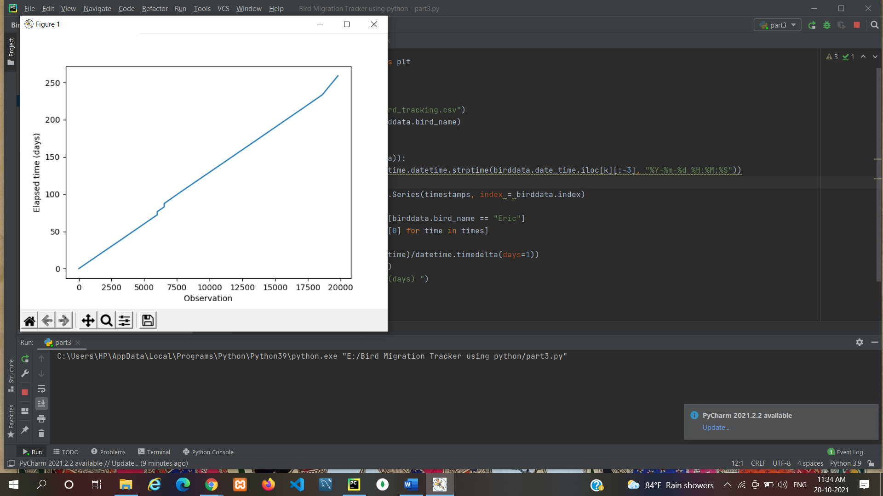

**PART (4/5): Daily Mean Speed**   
We are going to visualize the daily mean speed of the gull named “Eric” for the total number of days of recorded flight.

import pandas as pd  
import matplotlib.pyplot as plt  
import datetime  
import numpy as np  
  
birddata = pd.read_csv("bird_tracking.csv")  
bird_names = pd.unique(birddata.bird_name)  
  
timestamps = []  
for k in range(len(birddata)):  
 timestamps.append(datetime.datetime.strptime(birddata.date_time.iloc[k][:-3], "%Y-%m-%d %H:%M:%S"))  
birddata["timestamp"] = pd.Series(timestamps, index = birddata.index)  
  
data = birddata[birddata.bird_name == "Eric"]  
times = data.timestamp  
elapsed_time = [time-times[0] for time in times]  
elapsed_days = np.array(elapsed_time)/datetime.timedelta(days=1)  
  
next_day = 1  
inds = []  
daily_mean_speed = []  
for (i,t) in enumerate(elapsed_days):  
 if t < next_day:  
 inds.append(i)  
 else:  
 daily_mean_speed.append(np.mean(data.speed_2d[inds]))  
 next_day += 1  
 inds = []  
  
plt.figure(figsize = (8,6))  
plt.plot(daily_mean_speed, "rs-")  
plt.xlabel(" Day ")  
plt.ylabel(" Mean Speed (m/s) ");  
plt.show()

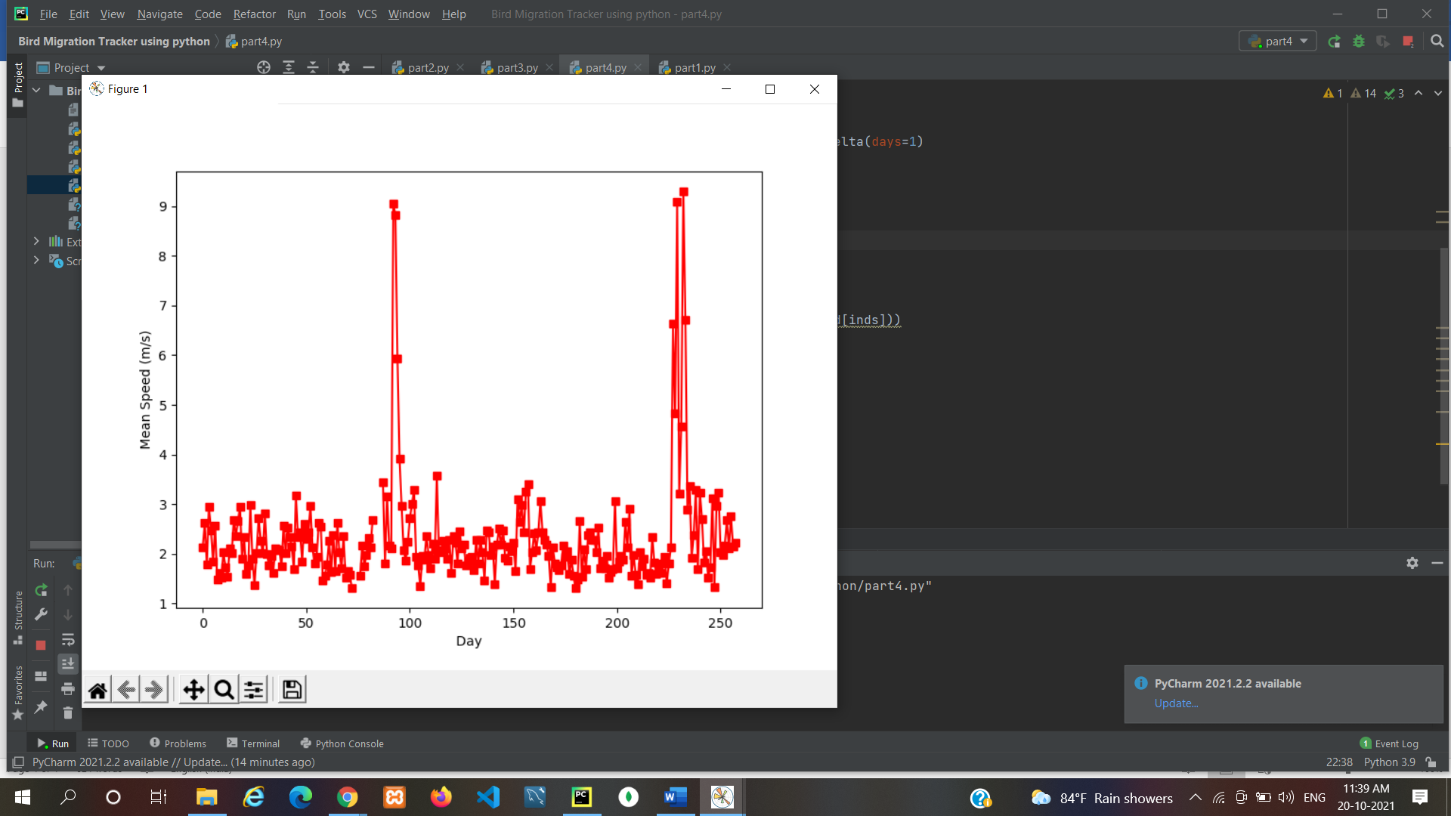

**PART (5/5): Cartographic View** -In this last part, we are going to track the Birds over a map.

import pandas as pd  
import cartopy.crs as ccrs  
import cartopy.feature as cfeature  
import matplotlib.pyplot as plt  
  
birddata = pd.read_csv("bird_tracking.csv")  
bird_names = pd.unique(birddata.bird_name)  
  
# To move forward, we need to specify a  
# specific projection that we're interested  
# in using.  
proj = ccrs.Mercator()  
  
plt.figure(figsize=(10,10))  
ax = plt.axes(projection=proj)  
ax.set_extent((-25.0, 20.0, 52.0, 10.0))  
ax.add_feature(cfeature.LAND)  
ax.add_feature(cfeature.OCEAN)  
ax.add_feature(cfeature.COASTLINE)  
ax.add_feature(cfeature.BORDERS, linestyle=':')  
for name in bird_names:  
 ix = birddata['bird_name'] == name  
 x,y = birddata.longitude[ix], birddata.latitude[ix]  
 ax.plot(x,y,'.', transform=ccrs.Geodetic(), label=name)  
plt.legend(loc="upper left")  
plt.show()

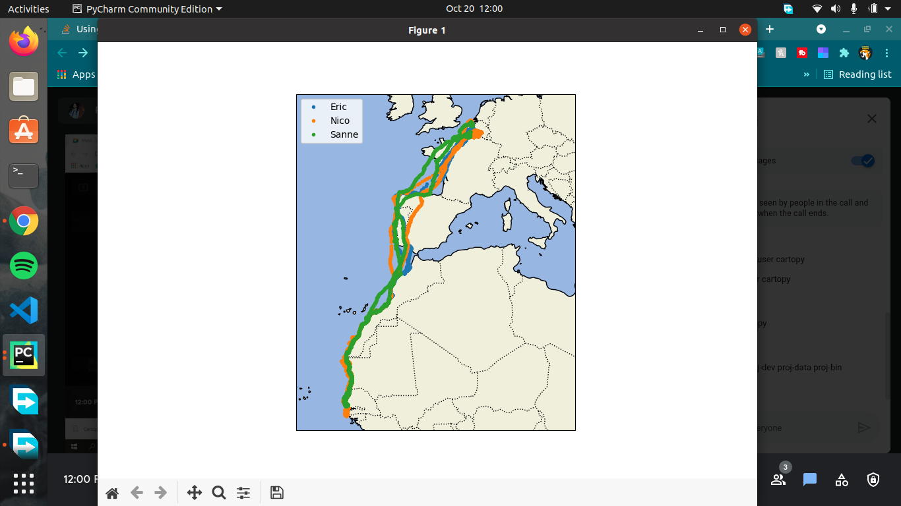

**Resources :**

1. edX – HarvardX – Using Python for Research

2. Python functions doc_I

3. Python functions doc_II